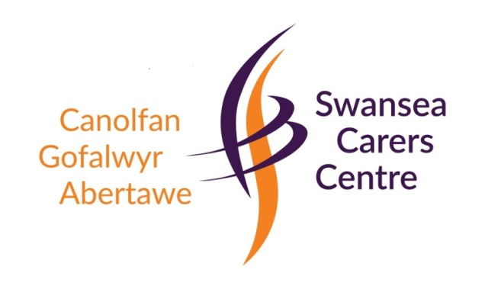
SERVICES TO CARERS
DURING CORONAVIRUS PANDEMIC
The Covid-19 outbreak and our nation's response to it brings competing challenges as we seek to continue to provide essential services, take care of our staff, and provide as much support to carers and their families as we can.
Swansea Carers Centre is launching three new helpline services to offer carers further support during this difficult period. We recognise this situation continues to evolve at pace and are constantly monitoring our services and reviewing decisions and processes.
From today, both Swansea Carers Centre and Ty Conway are closed to the general public and all groups and activities postponed. We would urge carers to take advantage of the new helpline services where our staff will do their best to offer support and advice or just to hear a friendly voice during this time.

Carer Support Helpline: 01792 653344 / 07984 445465
Counselling Support Helpline: 01792 653344 / 07984 445484
Benefits Advice line: 07984 445493/ 07984 445491
Please note these help lines are operating between
Monday – Friday 9.30am – 4pm.
They are not 24 hours
@Swansea Carers Centre

