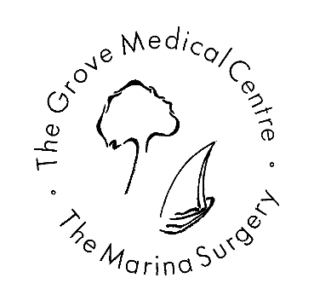
Subject Access Request Form
By completing this form, you are making a request under the General Data Protection Regulation (GDPR) for information held about you by the practice that you are eligible to receive.
In accordance with legislation, no fee will be charged for your request, unless the request is manifestly unfounded or excessive, particularly if it is repetitive.
You will be required to provide two forms of identification;
- Photo ID
- Confirmation of address
On completion of this form and the required forms of identification, your requested information will be ready for collection from The Grove Medical Centre one calendar month from the date the request was received by the practice.
About yourself
Surname:
Forename(s):
Date of Birth:
Address:

NHS No:
Home Tel: |  | Mobile Tel:
Required information
I would like a copy of all medical records ☐

I would like a copy of records between specific dates only (please give date range) ☐

I would like a copy or records relating to a specific condition or specific incident only (please give full details) ☐

Declaration
By signing below, you indicate that you are the individual named above. The practice cannot accept requests regarding your personal data from anyone else, including family members, without written consent from all parties.
I ……………………………….…………………………………………………………….…………………… certify that the information provided on this application to The Grove Medical Centre/Marina Surgery is true. I understand that it is necessary for the practice to confirm the data subject’s identity and that it may be necessary for the practice to request more details from me in order to process this request.
Signature: …………………………………………………………………………………. Date: …………………………………………………………………
Please return the completed form to:

The Grove Medical Centre
6 Uplands Terrace
Uplands
Swansea SA2 0GU

FOR OFFICE USE ONLY

Date request received with ID documentation / /

Date request completed / /

