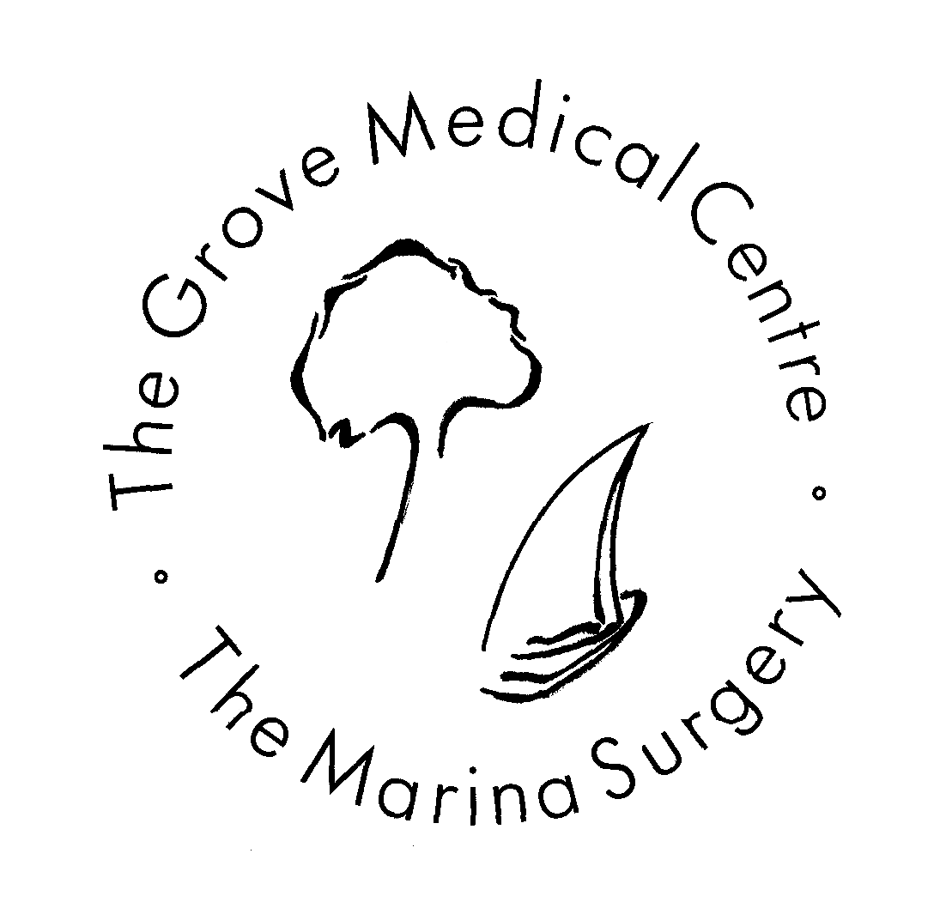

This leaflet is updated regularly and
reviewed on an annual basis.
This leaflet can be provided in large
print if required.

Updated March 2023

Data Protection - Privacy Notice
- To view our privacy notice please visit our website:
www.grovemedicalcentre.wales.nhs.uk/

Practice telephone line: 01792 643000
(Open from 8.00 am to 6.30 pm Monday to Friday)
Practice prescription line: 01792 648049
(Open from 1.30 pm to 5.00 pm Monday to Friday)
Practice Email: practice.manager.w98023@wales.nhs.uk
Practice Website: www.grovemedicalcentre.wales.nhs.uk/


FIND US ON FACEBOOK
The Grove Medical Centre & Marina Surgery

Welcome to the Practice
The Practice runs from two sites “The Grove Medical Centre” and “The Marina Surgery” and operates as a General Partnership. Both sites are staffed with doctors, practice nurses, health care assistants, receptionists, and health visitors.
The Marina is a branch surgery and does not offer the range of services found at The Grove Medical Centre, but patients registered at The Marina can access these services at The Grove.
This leaflet is for existing patients and those considering registering with us. It tells you about the services we provide, how to access them and some general information about how the practice operates.
The Practice recognises the different needs of patients with disabilities and our aim is to meet these needs flexibly and with sensitivity.

New Patient Registration
If you live within our practice area and would like to register with the practice, please complete a registration form, which is available at reception in both the Grove and Marina Surgeries.
You will be able to say which practitioner you would prefer to see, however, you will be registering with the practice rather than an individual GP.
If you are unsure if you live within our practice area, please visit our website and view our interactive practice map.
www.grovemedicalcentre.wales.nhs.uk/

The Grove Medical Centre (Main Surgery)
Reception desk
Monday to Friday 8.00 am to 6.30 pm

The Marina Surgery (Branch Surgery)
Reception desk
Monday, Tuesday and Friday 9.00 am to 1.00 pm
2.00 pm to 6.00 pm
Wednesday and Thursday 9.00 am to 1.00 pm

GP Registrars and Medical Students
The practice is a training practice, so from time to time there may be a GP registrar or medical students at the surgery.
GP registrars are fully qualified doctors and provide the same standard of care as the other doctors at the practice.
You will be informed if there is a medical student with the doctor when you book in at reception for your appointment.
If you do not want a medical student present during your consultation, please inform the receptionist; this is your right and it will not affect your consultation.

Carer Information
If you are a carer or someone looking after a relative, please ask at reception for a Carers Information Pack.

Appointments, advice and test results
All patients presenting with a new problem, appropriate for a GP assessment, will be offered a face-to-face appointment without the need for a GP to triage the appointment first. Our care navigators in reception will still signpost patients to alternative healthcare services such as pharmacy, physio or optician, if more appropriate. This is essential to ensure the GPs have time to see the patients that really need their attention.
You can also contact the practice Monday to Friday via AskmyGP between the hours of 7.30 am to 11.00 am and patients will then be called back by a care navigator in reception to be booked a face-to-face appointment. Telephone and e-consulting will still be available for follow-up appointments or simple queries. House calls are undertaken if considered appropriate by the doctor. Requests will be assessed following a telephone consultation. You will be asked to keep your telephone line clear to enable the doctor to ring you back
You can access Ask My GP through our website at:
www.grovemedicalcentre.wales.nhs.uk/

Out of Hours Emergencies
The surgery will be closed between 6.30 pm and 8.00 am Monday to Friday and all day on Saturday, Sunday and Bank Holidays.
If you need urgent advice, please telephone the GP Out-of-Hours Service on 111, this number is also available as a recorded message on our telephone systems when the practice is closed.
In the event of a Medical Emergency please ring 999
The Out of Hours Service is commissioned by
Swansea Bay University Health Board.

Repeat Prescriptions
Repeat prescriptions can be ordered as follows giving 72 hours notice Monday to Friday. You can order your repeat prescription by:
- Using our Online Service called My Health On-line (which is available 24 hours a day). If you wish to register for this service please speak to a receptionist or visit the practice website: www.grovemedicalcentre.wales.nhs.uk/
- Telephoning the prescription line 01792 648049 Monday to Friday, between 1.30 pm to 5.00 pm
- In person by ticking items required on the computer list or filling out a prescription request slip and placing in script request box
- In writing enclosing an SAE if you wish the prescription to be posted back to you, but please note we cannot guarantee delivery by the postal service.
Please note that repeat prescriptions are NOT written on a weekend so never leave it to the last minute to order a repeat prescription. You can collect prescriptions during reception opening hours. Please leave the required 72 hours after you have ordered the prescription or you may have a wasted journey.
Chemists arrange for prescriptions to be collected after 11.00 am Monday to Friday

Medication reviews
Patients on repeat medication will be asked to see/speak to a doctor, nurse or practice pharmacist at least once a year to review any regular medications and notifications may appear on your repeat slip.
Please ensure that you book an appropriate consultation to avoid unnecessary delays to further prescriptions when asked to do so.

Medical Sickness Certificates
If you consider that you are too ill to work, you can sign yourself off work for the first 7 days using a Self Certificate form obtainable from your employer. If you are off work for more than 7 days your doctor can provide an NHS certificate following a consultation.
If your employer requires a certificate for the first 7 days a private certificate can be issued, there is a fee payable for this.

Additional Services
The following services are available at The Grove Medical Centre to all patients registered with the practice.
All clinics require an appointment and some require a GP referral.

- Antenatal Clinic
- Anticoagulation Monitoring
- Chronic Disease Monitoring
- Cryotherapy Clinic
- Family Planning Clinic
- Minor ops clinic
- Well Baby Clinic

Child Health
The practice provides a full immunisation service and runs a Child Development Clinic in association with the Health Visitors at The Grove Medical Centre. Please note that Marina patients will be invited to attend the Child Development Clinic at The Grove Medical Centre, as no childhood vaccines are given in the Marina Surgery.

Family Planning
The practice nurses will provide advice on family planning, including oral contraception and injectable contraception.
Emergency contraction is available at local pharmacies or at the practice.
Coil and Nexplanon insertion is available following consultation with a GP and performed in our Family Planning Clinic.
Patients can also obtain advice on contraception by visiting:
https://www.nhs.uk/conditions/contraception/which-method-suits-me/

Cervical Screening
When you receive an invitation letter for a smear from Cervical Smear Wales (CSW) please call the surgery for an appointment. These are booked during normal surgery times and are carried out by our specially trained practice nurses. Cervical screening will commence at the age 25 for first call (invitations issued at 24 years 6 months).
Women will be recalled for screening every 5 years between the ages of 25 to 64.
If HPV is not found in your next routine cervical screening sample, then your next invitation will be in five years, regardless of age. This is because evidence tells us that the risk of developing cervical cancer is very low.
HPV is the primary test, screening is only performed before 5 years if instructed by Wales Cervical Screening.
Further information on cervical screening can be found by visiting:
https://phw.nhs.wales/services-and-teams/cervical-screening-wales/what-is-cervical-screening/

Travel Advice
Patients wishing advice on travel vaccination should present 4 to 6 weeks prior to travel.
The practice is only able to offer basic travel advice and can only offer the following NHS vaccines:
- Hepatitis A
- Typhoid
- MMR
- Diptheria
- Tetanus
- Polio
Please note Hepatitis B is not given free for travel.
All other vaccines are chargeable, and patients must seek these privately as the surgery does not give or offer these vaccines.
For further information on obtaining these chargeable vaccinations, can be found by following the links below:

https://www.nhs.uk/conditions/travel-vaccinations/
https://travelhealthpro.org.uk
https://masta-travel-health.com
https://www.boots.com/health-pharmacy-advice/vaccinations
https://healthclinics.superdrug.com

Car Parking
The Grove Medical Centre has its own car park which will accommodate approximately 22 cars. Please do not block any entrances or exits as ambulances require access throughout the day.
The car parking on this site is patrolled by a management company, accredited member of the British Parking Associate. Please read the signage with regard to parking permits. Patients visiting the surgery can obtain a free parking permit from reception during their visit.
The Marina Surgery has no parking facilities owing to the waterfront location, but pay and display car parks are available nearby.

Disabled Access and Facilities
The Grove Medical Centre has disabled access to a waiting room, toilet with facilities for the disabled, two consulting rooms, and a nurse treatment room for wheelchair users.
At The Marina Surgery access for patients in wheelchairs is limited but possible.
Other facilities available include:
- A stair lift is available for use to other parts of the building.
- An induction loop hearing system for the hard of hearing.
- Practice information leaflet in large print and on CD format for the visually impaired are available on request.
- Special provisions can be made for patients with learning difficulties.
- Interpreters can be arranged with prior notice.
If you have any difficulty, please inform the receptionist.

The Primary Health Care Team
Partners (Operates as a General Partnership)
- Dr Ashok Rayani
- Dr Jack Williams
- Dr Sara Swan
- Dr Jo Allchurch
- Dr Mike Sorensen
Salaried GPs
- Dr Rachel Thomas
- Dr Sam Soul
Practice Nurses
- Lead Practice Nurse: Kelly Di’iulio
- Practice Nurse: Samantha Evans
The Practice Nurses deal with immunisations, contraception, cervical smears, health promotion, chronic disease management, simple dressings and various other health tests.
Health Care Assistant (HCA)
- HCA: Donna Clarke-Davies and Gareth Apajee
Our Health Care Assistant deals with simple dressings, blood pressure monitoring, new patient checks, ECG’s and various other health tests.
Practice Manager
Mrs Lorraine Flower is responsible for the smooth running and the organisation of the practice.

Assistant Practice Manager / Medical Secretary
Ms Carol Wilson assists the Practice Manager with the smooth running of the practice and is responsible for all secretarial services to the partners of the practice.
Reception Supervisors
Mrs Ruth Lees and Mrs Kelly Dicks support the reception team and help with the smooth running of the practice.
Care Navigators (receptionists)
We have an experienced team of receptionists who are trained to help you access our services. They will often need to ask you for further details when you telephone to ensure that we deal with you as effectively as possible. They are bound by the same rules of confidentiality as the doctors.
Health Visitor
The Health Visitor is available to give advice on healthcare for expectant mothers, babies, and children under 5 years of age.
Mental Health Liaison Nurse
We have a MHLN attached to the practice and provides help with depression, stress and other life issues, by referral from a GP.
Midwife
The ante-natal clinic is midwife led, supporting and visiting patients in their own homes during pregnancy.

Non-NHS Examinations and Work
Medical examinations for private purposes which fall outside NHS provision are done outside consulting hours. These include taxi, HGV and insurance medicals, fitness for certain sports and pre-employment. These examinations can be arranged by the receptionist and a fee will be charged.
Please ask the receptionist for the fee structure, the fee will be payable at the time of the examination. All forms needing completion by a GP will attract a fee which will need to be paid in advance.

Priority NHS Healthcare for Veterans
All war veterans can now receive priority access to NHS secondary care for any condition which is likely to be related to their service. Those entitled to priority treatment for conditions related to services are:
- All Army, Navy and Air Force personnel who served at least one day and are considered veterans for this purpose
- Reservists
- Former members of the Merchant Navy who took a direct part in legally-defined UK military operations.
Priority treatment ONLY applies to conditions which are related to veterans’ service.
Patients are under no obligation at any time to declare themselves a veteran. They may, however, wish to discuss this entitlement with their GP during a consultation for treatment of a condition related to service.
Veterans can also contact the Veterans-UK helpline on
0800 169 2277 should they have any queries.

Rights and Responsibilities
When you register with the practice you are entering into a contract with us.
Practice Values
- The practice will manage medical conditions according to the highest standards as defined by the profession.
- All staff will treat you with courtesy and respect.
- You will receive appropriate information regarding your medical condition and treatment.
- Partners, nurses and staff will be encouraged to undertake appropriate further training.
Patients Responsibilities
- Patient should attend their consultations at the arranged times and if this is not possible should inform the practice as soon as possible.
- Patients should understand that consultations are for one person only. A further consultation should be booked for more than one person.
- Patients are responsible for their own health and the health of their children and should co-operate with the practice in trying to keep them healthy.
- House call requests should only be made for those who are housebound or terminally ill. Most medical problems are dealt with more effectively in the clinical setting of a surgery.
- We ask that patients treat the staff and doctors with respect and courtesy. The practice operates a zero-tolerance policy with regard to aggression and violence towards staff and doctors.
- Patients moving outside the practice area will be asked to register with a nearer GP.

Complaints or Suggestions
We aim to provide a high quality of service, but if you have any suggestions on how we could improve please write to the Practice Manager, put a suggestion in the suggestions box (just inside the front entrance) or tell one of the receptionists and she will pass on your suggestion.
If you are unhappy with any aspect of our service please contact the Practice Manager, record it and investigate where necessary. We shall acknowledge your complaint within 2 working days and aim to reply within 30 working days.

Violence and Abusive Behaviour - (Zero Tolerance Policy)
The Practice considers aggressive behaviour to be any personal, abusive and/or aggressive comments, cursing and/or swearing, physical contact and/or aggressive gestures.
As a statutory Health & Safety at Work measure, the practice will protect any member of staff from this kind of behaviour.
The practice will request the removal of any patient from the practice list who is aggressive or abusive towards a Doctor, member of staff, other patient, or who damages property.
All instances of actual physical abuse on any Doctor or member of staff, by a patient or their relatives will be reported to the police as an assault.
Before we end a professional relationship with a patient we will:
- Warn the patient that we are considering ending the relationship
- Do what we can to restore the professional relationship
- Explore alternatives to ending the professional relationship
- Discuss the situation with an experienced colleague.

The Bay Health Cluster Network/GP Collaborative
The Grove Medical Centre is part of the Bay Health Cluster Network, and is made up of 7 other GP Practices:
- Mumbles Medical Practice and Murton Surgery
- Uplands and Mumbles Surgery
- Gower Medical Practice – Pennard Surgery (Branch Practice)
- Kings Road Surgery
- Sketty and Killay Medical Centres
- St Thomas & West Cross Surgeries
- University Health Centre Swansea
What are Cluster Networks/GP Collaboratives?
They provide a new way in which GP Practices and a range of health, social care and voluntary sector professionals will work more closely together.
Cluster Networks/GP Collaboratives will:
Focus on preventing ill health, enabling people to keep themselves well and independent for as long as possible. Develop the range and quality of services that are provided in the community.
Ensure services provided by a wide range of health and social care professionals in the community are better co-ordinated to local needs.
Improve communication and information sharing between different health, social care and voluntary sector professionals.
Facilitate closer working between community based and hospital services, ensuring that patients receive a smooth and safe transition from hospital services to community based services and vice versa.
Services available for GPs to refer patients to include:
- First Contact Practitioner/Physio Triage System
- Community Specialist Nurses
- Mental Health Services
- Audiology Services
Useful telephone numbers
SBUHB Appointments Office | 01792 583700  ABM.AppointmentOffice@wales.nhs.uk
My Health Online Support for patients | mholsupport@wales.nhs.uk
Non-Emergency Patient Transport | 0300 123 2303
Singleton Hospital | 01792 205666
Morriston Hospital | 01792 702222
Neath Port Talbot Hospital | 01639 862000
Gorseinon Hospital | 01792 704184 or 01792 704180
Cefn Coed Hospital | 01792 561155
Out of Hours Service | 111
NHS Direct | 0845 46 47
Public Health Wales | 0300 00 300 32
Practice Health Visitor | 07581 239 779
Samaritans: call 116 123 free at any time
jo@samaritans.org (response time 24 hours)

Useful Addresses
Swansea Bay University Health Board Headquarters
1 Talbot Gateway
Baglan Energy Park
Baglan
Port Talbot SA12 7BR
Tel: 01639 683344
https://sbuhb.nhs.wales/

Swansea Bay Community Health Council
Cimla Health & Social Care Centre
Cimla
Neath
SA11 3SU
Tel: 01639 683490
Email: swanseabay@waleschc.org.uk
https://swanseabaychc.nhs.wales/
The Community Health Council is independent of the
NHS and can offer help advice and advocacy

Practice Area
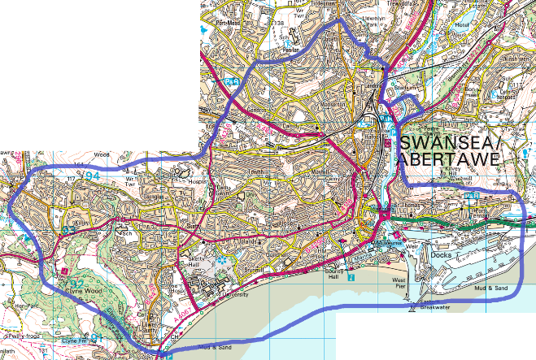
The practice covers a large area of Swansea in postcodes SA1 and SA2. This includes Swansea central, The Marina, Uplands, Sketty, and Killay, but please contact our receptionists if you require further details.

